7.0.4 Editors - 3D View - Mesh Object - Edit Mode - Face Context Menu
Detailed table of content 1
Face Context Menu 5
Subdivide 5
Extrude Faces 6
Extrude Along Normals 7
Extrude Individual 8
Poke Faces 9
UV Unwrap Faces 9
Triangulate Faces 14
Tris to Quads 15
Shade Smooth 16
Shade Flat 16
Un-Subdivide 16
Split 16
Separate 16
Dissolve Faces 17
Delete Faces 17

Detailed table of content

Detailed table of content
Detailed table of content 1
Face Context Menu 5
Subdivide 5
Last Operator Subdivide 5
Number of Cuts 5
Smoothness 5
Create N-Gons 5
Quad Corner Type 5
Fractal 6
Along Normal 6
Random Seed 6
Extrude Faces 6
Last Operator Extrude Region and Move 6
Flip Normals 6
Move X, Y Z 6
Orientation 6
Proportional editing 6
Proportional Falloff 6
Proportional Size 6
Connected 7
Projected(2D) 7
Extrude Along Normals 7
Header Value 7
Last Operator Extrude Region and Shrink/Fatten 7
Flip Normals 7
Offset 7
Offset Even 7
Proportional editing 7
Proportional Falloff 7
Proportional Size 7
Connected 8
Projected(2D) 8
Extrude Individual 8
Header Value 8
Last Operator Extrude Individual Faces and Move 8
Offset 8
Offset Even 8
Proportional editing 8
Proportional Falloff 8
Proportional Size 8
Connected 8
Projected(2D) 9
Poke Faces 9
Last Operator Poke Faces 9
Poke Offset 9
Offset Relative 9
Poke Center 9
UV Unwrap Faces 9
Unwrap ABF 10
Unwrap Conformal 10
Last Operator Unwrap 10
Method 10
Fill Holes 10
Correct Aspect 10
Use Subsurf Modifier 10
Margin 10
Smart UV Project 10
Smart UV Project Settings dialogue 10
Angle Limit 10
Island Margin 10
Area Weight 10
Correct Aspect 11
Last Operator Smart UV Project 11
Light map Pack 11
Settings 11
Selection 11
Share Tex Space 11
New UV Map 11
New Image 11
Image Size 11
Pack Quality 11
Margin 11
Follow Active Quads 11
Settings 12
Edge Length Mode 12
Last Operator Follow Active Quads 12
Cube Projection 12
Last Operator Cube Projection 12
Cube Size 12
Correct Aspect 12
Clip to Bounds 12
Scale to Bounds 12
Cylinder Projection 12
Last Operator Cylinder Projection 12
Direction 12
Align 12
Radius 12
Correct Aspect 12
Clip to Bounds 13
Scale to Bounds 13
Sphere Projection 13
Last Operator Sphere Projection 13
Direction 13
Align 13
Correct Aspect 13
Clip to Bounds 13
Scale to Bounds 13
Project from View 13
Last Operator Project from View 13
Orthographic 13
Camera Bounds 13
Correct Aspect 13
Clip to Bounds 13
Scale to Bounds 14
Project from View (Bounds) 14
Mark Seam 14
Clear Seam 14
Reset 14
Triangulate Faces 14
Last Operator Triangulate Faces 14
Quad Method 14
Shortest diagonal 14
Fixed Alternate 15
Fixed 15
Beauty 15
Polygon Method 15
Clip 15
Beauty 15
Tris to Quads 15
Last Operator Tris to Quads 15
Max Face Angle 15
Max Shape Angle 15
Compare UV's 15
Compare VCols 15
Compare Seam 15
Compare Sharp 15
Compare Materials 16
Shade Smooth 16
Shade Flat 16
Un-Subdivide 16
Last Operator Un-Subdivide 16
Iterations 16
Split 16
Separate 16
Selection 17
By Material 17
By Loose Parts 17
Dissolve Faces 17
Last Operator Dissolve Vertices 17
Dissolve Verts 17
Delete Faces 17

Face Context Menu

Call this menu with double right click in the 3D viewport. You need to be in Edit mode with a Mesh object. And in selection mode Edge.

Select geometry to reveal all content.
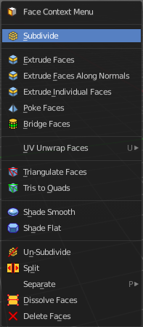
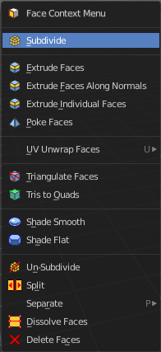

Subdivide
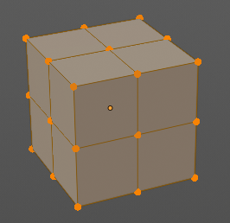
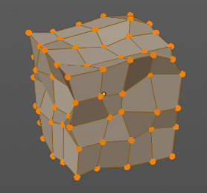
Subdivide divides the selected edges. It subdivides the involved faces too, and can create new vertices.
A more unknown functionality is that it can also randomize the result with the Fractal slider in the Last operator panel.

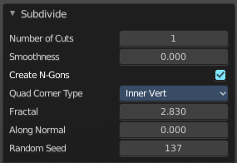
Last Operator Subdivide

Number of Cuts
The number of cuts defines the amount of subdivisions.

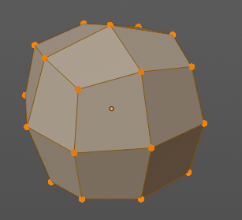
Smoothness
This value defines how smooth the subdivision result is. From flat to bent.

Create N-Gons
Create N-Gons if required. Else subdividing N-Gons creates Tris.

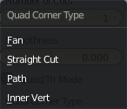
Quad Corner Type
Adjust the corner type.

Fractal
Randomize the selected vertices.

Along Normal
When randomized, this value defines how strong the subdivision follows the normals of the initial vertices.

Random Seed
Randomizing value for fractal randomizing.

Extrude Faces
Extrudes out the selected faces into the face direction by moving the mouse. When it's more than one face, then the middle will be used.

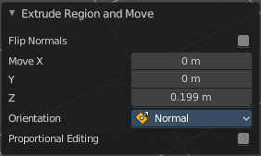
Last Operator Extrude Region and Move

Flip Normals
Flips the normals of the extruded faces.

Move X, Y Z
The position. Attention, the actual world orientation and rotation does not matter here. It always starts with a value of zero, and moves relative to this zero then. For the actual location values have a look in the sidebar in the transform panel.


Orientation
The widget can have different orientations. The menu items should be self explaining.


Proportional editing
Enables proportional editing. Activating proportional editing reveals further settings.

Proportional Falloff
Adjust the falloff methods.

Proportional Size
See and adjust the falloff radius.

Connected
The proportional falloff gets calculated for connected parts only.

Projected(2D)
The proportional falloff gets calculated in the screen space. Depth doesn't play a role. When it's in the radius, then it gets calculated.

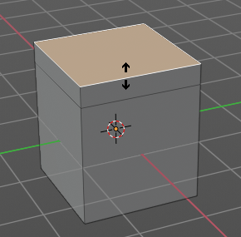
Extrude Along Normals
Extrudes the selection along local normals.

Header Value
This tool works like a shrink fatten extrude. And so you will see a corresponding set of values in the header.

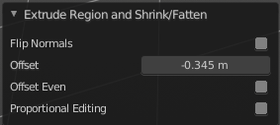
Last Operator Extrude Region and Shrink/Fatten

Flip Normals
Flips the normals of the extruded faces.

Offset
The current extrude amount.

Offset Even
Scales the offset to give more even thickness. Without this checked the farer away faces will have a bigger extrude amount.

Proportional editing
Enables proportional editing. Activating proportional editing reveals further settings.

Proportional Falloff
Adjust the falloff methods.

Proportional Size
See and adjust the falloff radius.

Connected
The proportional falloff gets calculated for connected parts only.

Projected(2D)
The proportional falloff gets calculated in the screen space. Depth doesn't play a role. When it's in the radius, then it gets calculated.

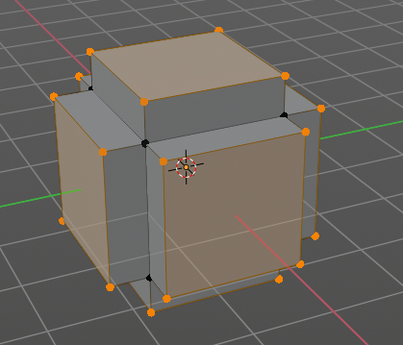
Extrude Individual
Extrudes the selection along local normals of each individual face.
The method works the same in all Mesh select modes. Vertice, Edge and Face Mode.

Header Value
This tool works like a shrink fatten extrude. And so you will see a corresponding set of values in the header.

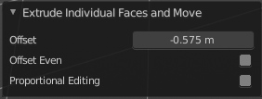
Last Operator Extrude Individual Faces and Move

Offset
The current extrude amount.

Offset Even
Scales the offset to give more even thickness. Without this checked the farer away faces will have a bigger extrude amount.

Proportional editing
Enables proportional editing. Activating proportional editing reveals further settings.

Proportional Falloff
Adjust the falloff methods.

Proportional Size
See and adjust the falloff radius.

Connected
The proportional falloff gets calculated for connected parts only.

Projected(2D)
The proportional falloff gets calculated in the screen space. Depth doesn't play a role. When it's in the radius, then it gets calculated.

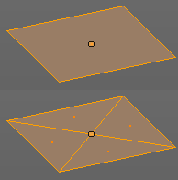
Poke Faces
Splits the selected faces to create a triangulated geometry.

Last Operator Poke Faces

Poke Offset
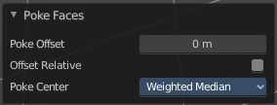
Normally the center vertice of the poke operation is planar with the rest. Adjust an offset.

Offset Relative
Scale the offset by surrounding geometry.
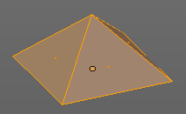

Poke Center
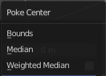
Poke Center is a drop-down box choose what the center of the poke operation should be. You can choose between weighted mean, mean and bounds.

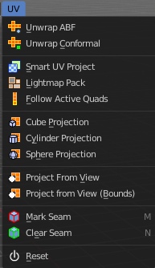
UV Unwrap Faces
The UV menu from the header.
Here you find the UV mapping methods and some further functionality. You use it best in the U Editing layout. There you can see the result in the UV Editor then.

The UV menu is just available for Mesh objects.

Unwrap ABF
Unwrap ABF unwraps the selected geometry with the method Angle based. ABF stands for Angle Based Flattening. ABF can give a bit better result than LSCM when unwrapping organic shapes.

Unwrap Conformal
Unwrap Conformal unwraps the selected geometry with the method LSCM, which is the short for Least Square Conformal Mapping. LSCM can give a bit better results than ABF with geometric shapes.

Last Operator Unwrap
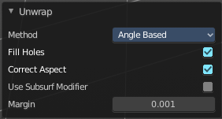
Unwrap ABF and Unwrap LSCM shares the same Last Operator.

Method
Method is a drop down box where you can choose between Unwrap method Angle Based and Conformal.

Fill Holes
Fill holes in the mesh before unwrapping.

Correct Aspect
Take the Image Aspect Ratio into account.

Use Subsurf Modifier
Unwraps an existing Subsurf Modifier. You need to add a Subsurf Modifier first.

Margin
The distance between the single UV patches.

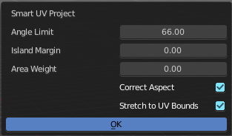
Smart UV Project
Smart UV Project projects the UV mapping from different angles.

Smart UV Project Settings dialogue

Angle Limit
The Angle Limit defines after which angle the mapping happens from the next side. With an angle of 66 you have around six sides to map from. The calculation is 360/66.

Island Margin
Island Margin defines the distance between the UV patches.

Area Weight
Weight Projection Vector by faces with larger areas.

Correct Aspect
Take the Image Aspect Ratio into account.

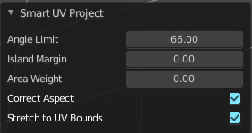
Last Operator Smart UV Project
The Last Operator for Smart UV Project contains the same settings than the Smart UV Project Settings dialogue.

Light map Pack
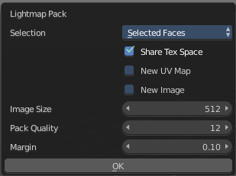
Light map Pack maps each face individually, and puts the result into the UV space. Without margin.
Light map Pack has no Last Operator.

Settings

Selection
Selection is a drop-down box where you can choose what will be packed.

Share Tex Space
Map all objects into one light map.

New UV Map
Create a new UV map for every new mesh.

New Image
Assign new Image to every new mesh.

Image Size
The size for new images.

Pack Quality
The pack quality.

Margin
The distance between the single UV patches.

Follow Active Quads
Follow Active quads maps UV coordinates starting from an active face, and maps all adjacent faces in quad shape then. This way you can for example unwrap a pipe or a road. You first need to have a face selected. Then select everything. And then click at Follow Active Quads.

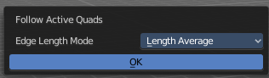
Settings

Edge Length Mode
Edge Length Mode is a drop-down box where you can choose the Length method.

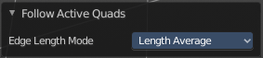
Last Operator Follow Active Quads
The Last Operator contains the same settings than the Settings dialogue.

Cube Projection
Cube Projection maps the mesh from six sides, means cubic.

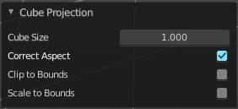
Last Operator Cube Projection

Cube Size
Cube Size defines the size of the UV mesh in the UV space.

Correct Aspect
Take Image Aspect ratio into account.

Clip to Bounds
Clip UV Coordinates to bounds after unwrapping.

Scale to Bounds
Scale UV Coordinates to bounds after unwrapping.

Cylinder Projection
Cylinder Projection tries to map the geometry cylindric.

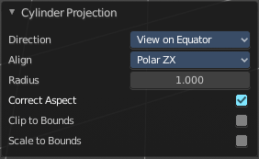
Last Operator Cylinder Projection

Direction
Direction is a drop-down box where you can choose in which direction the cylindric projection will be mapped.

Align
Align is a drop-down box where you can choose the Align method.

Radius
Radius defines the Polar size of the UV mesh in the UV space.

Correct Aspect
Take Image Aspect ratio into account.

Clip to Bounds
Clip UV Coordinates to bounds after unwrapping.

Scale to Bounds
Scale UV Coordinates to bounds after unwrapping.

Sphere Projection
Sphere Projection tries to map the geometry spherical.

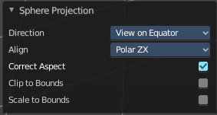
Last Operator Sphere Projection

Direction
Direction is a drop-down box where you can choose in which direction the spherical projection will be mapped.

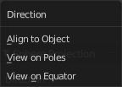
Align
Align is a drop-down box where you can choose the Align method.

Correct Aspect
Take Image Aspect ratio into account.

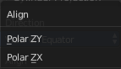
Clip to Bounds
Clip UV Coordinates to bounds after unwrapping.

Scale to Bounds
Scale UV Coordinates to bounds after unwrapping.

Project from View
Project from View projects the UV from the current 3D view.

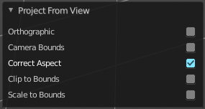
Last Operator Project from View

Orthographic
User orthographic projection.

Camera Bounds
Map UV's to the camera region taking resolution and aspect into account.

Correct Aspect
Take Image Aspect ratio into account.

Clip to Bounds
Clip UV Coordinates to bounds after unwrapping.

Scale to Bounds
Scale UV Coordinates to bounds after unwrapping.

Project from View (Bounds)
Project from View projects the UV from the current 3D view.
Same as Project from View, but with Scale to Bounds ticked in the Last operator. And so it scales to the bounds.

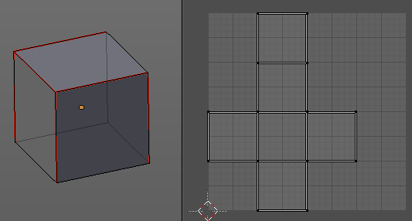
Mark Seam
The unwrap algorithms Angle based and Conformal requires to have edges marked as seams. Think of it as a cutting pattern for a trouser for example. Such a trouser is also made of fabric patterns.
Same goes for the UV patches when you use Angle based or conformal unwrapping. You need to cut your mesh into parts and mark edges as seams, so that the algorithm knows where the seams are.
Mark seam marks the currently selected edge(s) as a seam. Seam edges will be displayed as red in the 3D viewport.

Clear Seam
Clear seam removes the seam from the currently selected edge(s).

Reset
Resets the UV Projection.

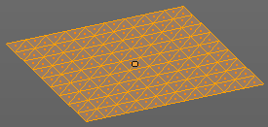
Triangulate Faces
Triangulate Faces triangulates the faces of the selected geometry.

Last Operator Triangulate Faces

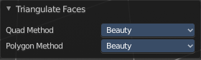
Quad Method
Choose how quads should be triangulated.

Shortest diagonal
Splits the quads based on their distance between vertices.

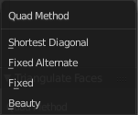
Fixed Alternate
Splits the quads on the second and fourth vertice.

Fixed
Splits the quads on the first and third vertice.

Beauty
Tries to optimize the triangulation.

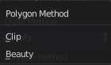
Polygon Method
Choose how N-Gons should be triangulated.

Clip
Splits the polygons with an ear clipping algorithm.

Beauty
Tries to optimize the triangulation.

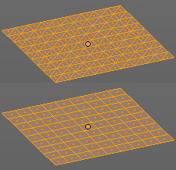
Tris to Quads
Tris to quads tries to convert triangulated geometry back to a quad geometry by removing the edges inside of the quads.

Last Operator Tris to Quads

Max Face Angle
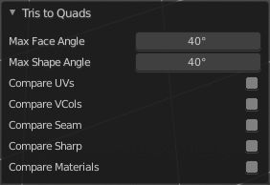
Adjust the threshold to adjacent triangles.

Max Shape Angle
Adjust the shape angle limit.

Compare UV's
Takes the UV patches for the calculation into account. Border geometry will not be calculated.

Compare VCols
Takes the Vertex colors for the calculation into account. Border geometry will not be calculated.

Compare Seam
Takes the Vertex colors for the calculation into account. Border geometry will not be calculated.

Compare Sharp
Takes the as sharp marked edges for the calculation into account. Border geometry will not be calculated.

Compare Materials
Takes the Materials colors for the calculation into account. Border geometry will not be calculated.

Shade Smooth
Sets the shading for the object to smooth. Flat means that every face of the object shows facettet, with a sharp edge. Smooth means that the edges are not longer to see.
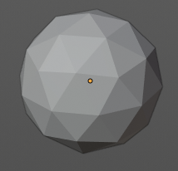
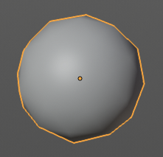

Shade Flat
Sets the shading for the object to flat. Flat means that every face of the object shows facettet, with a sharp edge. Smooth means that the edges are not longer to see.

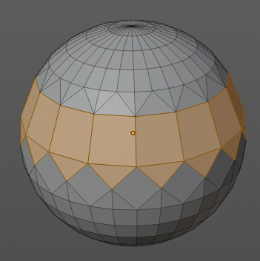
Un-Subdivide
Decimates the geometry by trying to make one quad out of four quads. But can also end in Tris where this is not possible.

Last Operator Un-Subdivide

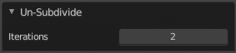
Iterations
Number of iterations. This means how deep the calculation should go. One level of SDS, two levels, three levels, etc. . Down to the point where you cannot decimate any geometry anymore.

Split
Splits the edges between the selected vertices. It creates two edges out of one. And splits the edge by that.

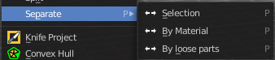
Separate
Separate separates the selected geometry, and creates a new object. The geometry becomes uneditable, since it is now a new object. You will have to leave the Edit mode, select the new object, and re-enter Edit mode when you want to edit it.

Selection
Selection separates the current selection.

By Material
By Material separates all geometry that has the same material than the current selection.

By Loose Parts
By Loose parts separates all geometry that is connected by edges to the current selection.

Dissolve Faces
Dissolves the selected faces, which unions the involved faces to one.

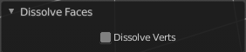
Last Operator Dissolve Vertices

Dissolve Verts
Dissolve remaining vertices.

Delete Faces
Deletes the selected faces.

